Output without scaling:

Label Latin Name ... Train Images Validation Images

0 n0 alouatta_palliata\t ... 131 26

1 n1 erythrocebus_patas\t ... 139 28

2 n2 cacajao_calvus\t ... 137 27

3 n3 macaca_fuscata\t ... 152 30

4 n4 cebuella_pygmea\t ... 131 26

5 n5 cebus_capucinus\t ... 141 28

6 n6 mico_argentatus\t ... 132 26

7 n7 saimiri_sciureus\t ... 142 28

8 n8 aotus_nigriceps\t ... 133 27

9 n9 trachypithecus_johnii ... 132 26

[10 rows x 5 columns]

0 mantled_howler

1 patas_monkey

2 bald_uakari

3 japanese_macaque

4 pygmy_marmoset

5 white_headed_capuchin

6 silvery_marmoset

7 common_squirrel_monkey

8 black_headed_night_monkey

9 nilgiri_langur

Name: Common Name, dtype: object

Found 1098 images belonging to 10 classes.

Found 272 images belonging to 10 classes.

pygmy_marmoset

/content/drive/My Drive/training/training/n4

n4052.jpg

(2912, 4368, 3)

n4

/content/drive/My Drive/training/training/n4

n4029.jpg

(435, 341, 3)

n4

/content/drive/My Drive/training/training/n4

n4037.jpg

(683, 1024, 3)

n4

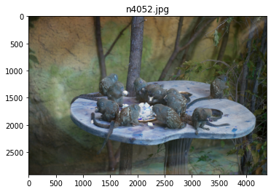

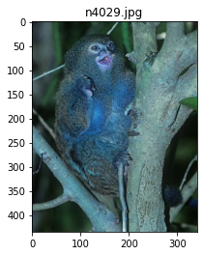

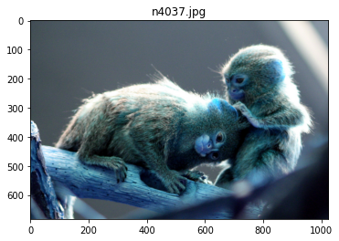

Train on 1098 samples, validate on 272 samples

Epoch 1/25

1098/1098 [==============================] - 1s 757us/step - loss: 288.7613 - accuracy: 0.0847 - val_loss: 2.3058 - val_accuracy: 0.0956

Epoch 2/25

1098/1098 [==============================] - 1s 467us/step - loss: 2.3042 - accuracy: 0.1029 - val_loss: 2.3046 - val_accuracy: 0.0956

Epoch 3/25

1098/1098 [==============================] - 0s 439us/step - loss: 2.3026 - accuracy: 0.1120 - val_loss: 2.3047 - val_accuracy: 0.0956

Epoch 4/25

1098/1098 [==============================] - 0s 430us/step - loss: 2.3038 - accuracy: 0.1111 - val_loss: 2.3037 - val_accuracy: 0.0956

Epoch 5/25

1098/1098 [==============================] - 0s 422us/step - loss: 2.3028 - accuracy: 0.1038 - val_loss: 2.3047 - val_accuracy: 0.0956

Epoch 6/25

1098/1098 [==============================] - 0s 448us/step - loss: 2.3026 - accuracy: 0.1111 - val_loss: 2.3041 - val_accuracy: 0.0956

Epoch 7/25

1098/1098 [==============================] - 0s 432us/step - loss: 2.3021 - accuracy: 0.1093 - val_loss: 2.3047 - val_accuracy: 0.0956

Epoch 8/25

1098/1098 [==============================] - 0s 438us/step - loss: 2.3029 - accuracy: 0.0956 - val_loss: 2.3042 - val_accuracy: 0.0956

Epoch 9/25

1098/1098 [==============================] - 0s 424us/step - loss: 2.3024 - accuracy: 0.1111 - val_loss: 2.3043 - val_accuracy: 0.0956

Epoch 10/25

1098/1098 [==============================] - 0s 435us/step - loss: 2.3025 - accuracy: 0.1111 - val_loss: 2.3039 - val_accuracy: 0.0956

Epoch 11/25

1098/1098 [==============================] - 0s 444us/step - loss: 2.3025 - accuracy: 0.1111 - val_loss: 2.3041 - val_accuracy: 0.0956

Epoch 12/25

1098/1098 [==============================] - 0s 431us/step - loss: 2.3022 - accuracy: 0.1111 - val_loss: 2.3044 - val_accuracy: 0.0956

Epoch 13/25

1098/1098 [==============================] - 0s 432us/step - loss: 2.3023 - accuracy: 0.1111 - val_loss: 2.3043 - val_accuracy: 0.0956

Epoch 14/25

1098/1098 [==============================] - 0s 423us/step - loss: 2.3021 - accuracy: 0.1111 - val_loss: 2.3047 - val_accuracy: 0.0956

Epoch 15/25

1098/1098 [==============================] - 0s 430us/step - loss: 2.3022 - accuracy: 0.1111 - val_loss: 2.3047 - val_accuracy: 0.0956

Epoch 16/25

1098/1098 [==============================] - 0s 433us/step - loss: 2.3023 - accuracy: 0.1111 - val_loss: 2.3046 - val_accuracy: 0.0956

Epoch 17/25

1098/1098 [==============================] - 0s 436us/step - loss: 2.3023 - accuracy: 0.1111 - val_loss: 2.3045 - val_accuracy: 0.0956

Epoch 18/25

1098/1098 [==============================] - 0s 421us/step - loss: 2.3024 - accuracy: 0.1111 - val_loss: 2.3046 - val_accuracy: 0.0956

Epoch 19/25

1098/1098 [==============================] - 0s 441us/step - loss: 2.3021 - accuracy: 0.1111 - val_loss: 2.3045 - val_accuracy: 0.0956

Epoch 20/25

1098/1098 [==============================] - 0s 437us/step - loss: 2.3020 - accuracy: 0.1111 - val_loss: 2.3048 - val_accuracy: 0.0956

Epoch 21/25

1098/1098 [==============================] - 0s 435us/step - loss: 2.3022 - accuracy: 0.1111 - val_loss: 2.3046 - val_accuracy: 0.0956

Epoch 22/25

1098/1098 [==============================] - 0s 438us/step - loss: 2.3023 - accuracy: 0.1111 - val_loss: 2.3045 - val_accuracy: 0.0956

Epoch 23/25

1098/1098 [==============================] - 0s 438us/step - loss: 2.3022 - accuracy: 0.1111 - val_loss: 2.3050 - val_accuracy: 0.0956

Epoch 24/25

1098/1098 [==============================] - 0s 427us/step - loss: 2.3023 - accuracy: 0.1111 - val_loss: 2.3042 - val_accuracy: 0.0956

Epoch 25/25

1098/1098 [==============================] - 0s 427us/step - loss: 2.3021 - accuracy: 0.1111 - val_loss: 2.3046 - val_accuracy: 0.0956

Model: "sequential_4"

_________________________________________________________________

Layer (type) Output Shape Param #

=================================================================

conv2d_13 (Conv2D) (None, 32, 32, 32) 896

_________________________________________________________________

dropout_10 (Dropout) (None, 32, 32, 32) 0

_________________________________________________________________

conv2d_14 (Conv2D) (None, 32, 32, 32) 9248

_________________________________________________________________

max_pooling2d_7 (MaxPooling2 (None, 16, 16, 32) 0

_________________________________________________________________

conv2d_15 (Conv2D) (None, 16, 16, 64) 18496

_________________________________________________________________

dropout_11 (Dropout) (None, 16, 16, 64) 0

_________________________________________________________________

conv2d_16 (Conv2D) (None, 16, 16, 64) 36928

_________________________________________________________________

max_pooling2d_8 (MaxPooling2 (None, 8, 8, 64) 0

_________________________________________________________________

flatten_4 (Flatten) (None, 4096) 0

_________________________________________________________________

dense_7 (Dense) (None, 512) 2097664

_________________________________________________________________

dropout_12 (Dropout) (None, 512) 0

_________________________________________________________________

dense_8 (Dense) (None, 10) 5130

=================================================================

Total params: 2,168,362

Trainable params: 2,168,362

Non-trainable params: 0

_________________________________________________________________

None

dict_keys(['val_loss', 'val_accuracy', 'loss', 'accuracy'])

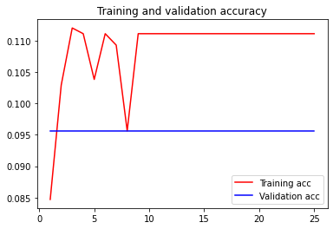

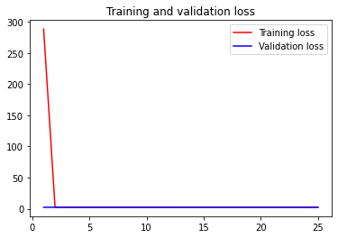

Model: "sequential_4"

_________________________________________________________________

Layer (type) Output Shape Param #

=================================================================

conv2d_13 (Conv2D) (None, 32, 32, 32) 896

_________________________________________________________________

dropout_10 (Dropout) (None, 32, 32, 32) 0

_________________________________________________________________

conv2d_14 (Conv2D) (None, 32, 32, 32) 9248

_________________________________________________________________

max_pooling2d_7 (MaxPooling2 (None, 16, 16, 32) 0

_________________________________________________________________

conv2d_15 (Conv2D) (None, 16, 16, 64) 18496

_________________________________________________________________

dropout_11 (Dropout) (None, 16, 16, 64) 0

_________________________________________________________________

conv2d_16 (Conv2D) (None, 16, 16, 64) 36928

_________________________________________________________________

max_pooling2d_8 (MaxPooling2 (None, 8, 8, 64) 0

_________________________________________________________________

flatten_4 (Flatten) (None, 4096) 0

_________________________________________________________________

dense_7 (Dense) (None, 512) 2097664

_________________________________________________________________

dropout_12 (Dropout) (None, 512) 0

_________________________________________________________________

dense_8 (Dense) (None, 10) 5130

=================================================================

Total params: 2,168,362

Trainable params: 2,168,362

Non-trainable params: 0

_________________________________________________________________

None

Loss: 2.304574629839729

Accuracy: 0.09558823704719543